Jenkins Pipeline Deployment – Step-by-Step Process

Step 1: Login to Jenkins
- Open the Jenkins URL in a web browser.
- Log in using the admin username and password.
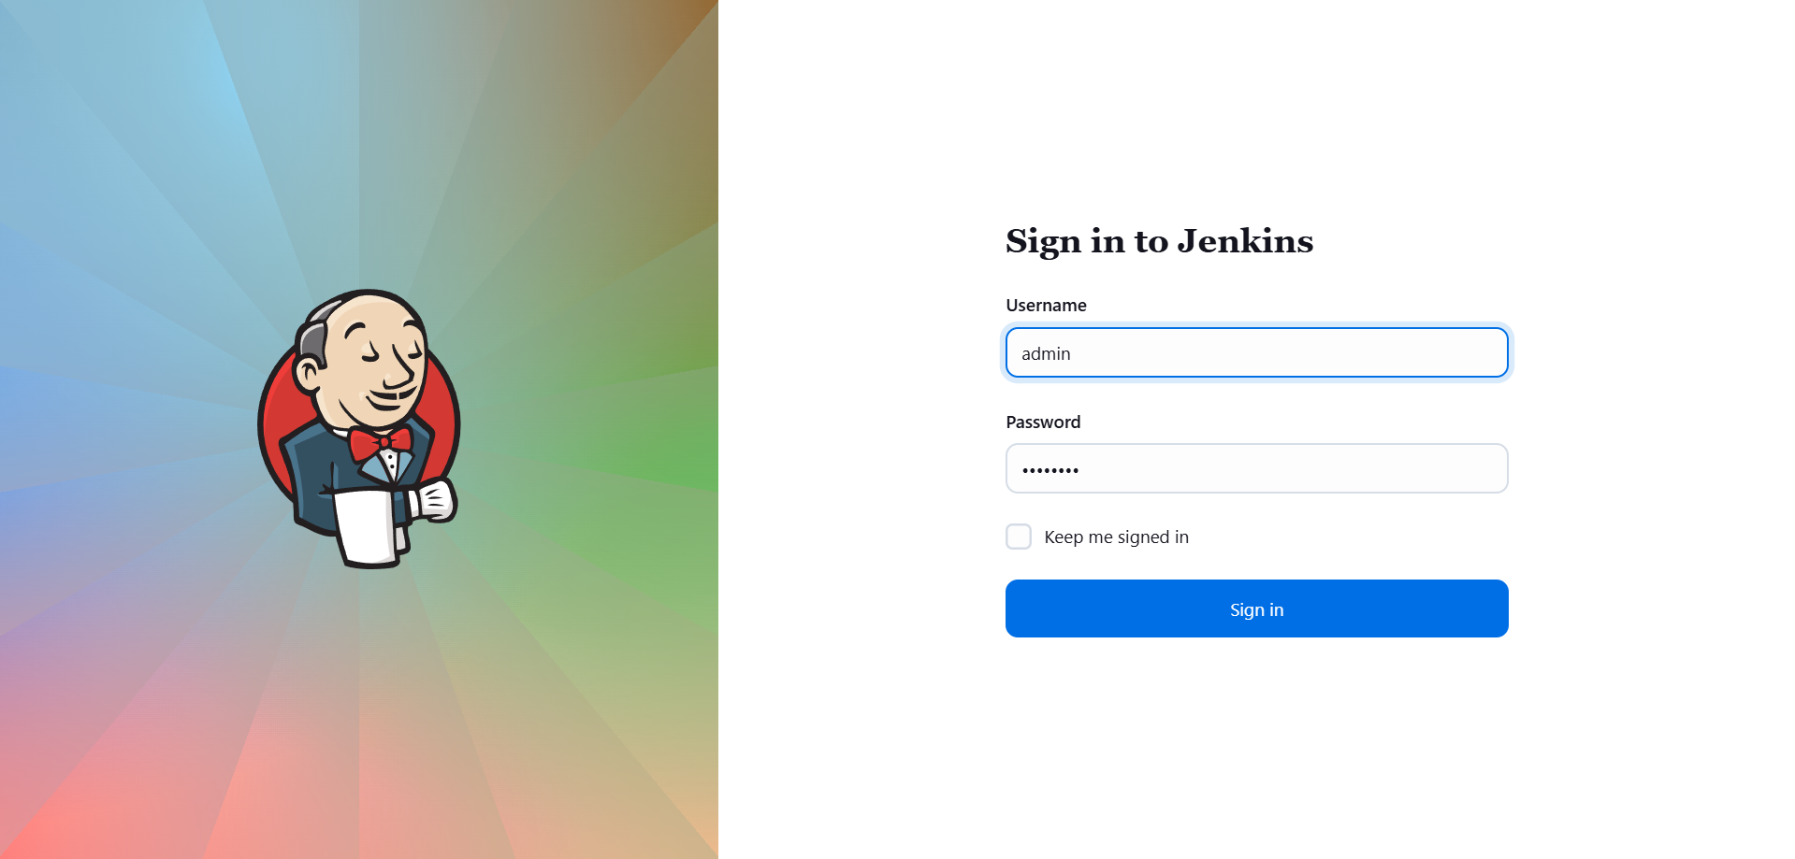
- Verify that the Jenkins dashboard loads successfully.

Step 2: Install Required Plugins
- Navigate to Manage Jenkins → Plugins → Available plugins.
- Search for and select the following plugins:
  - SSH Build Agents
  - Pipeline
  - Git
- Click Install.
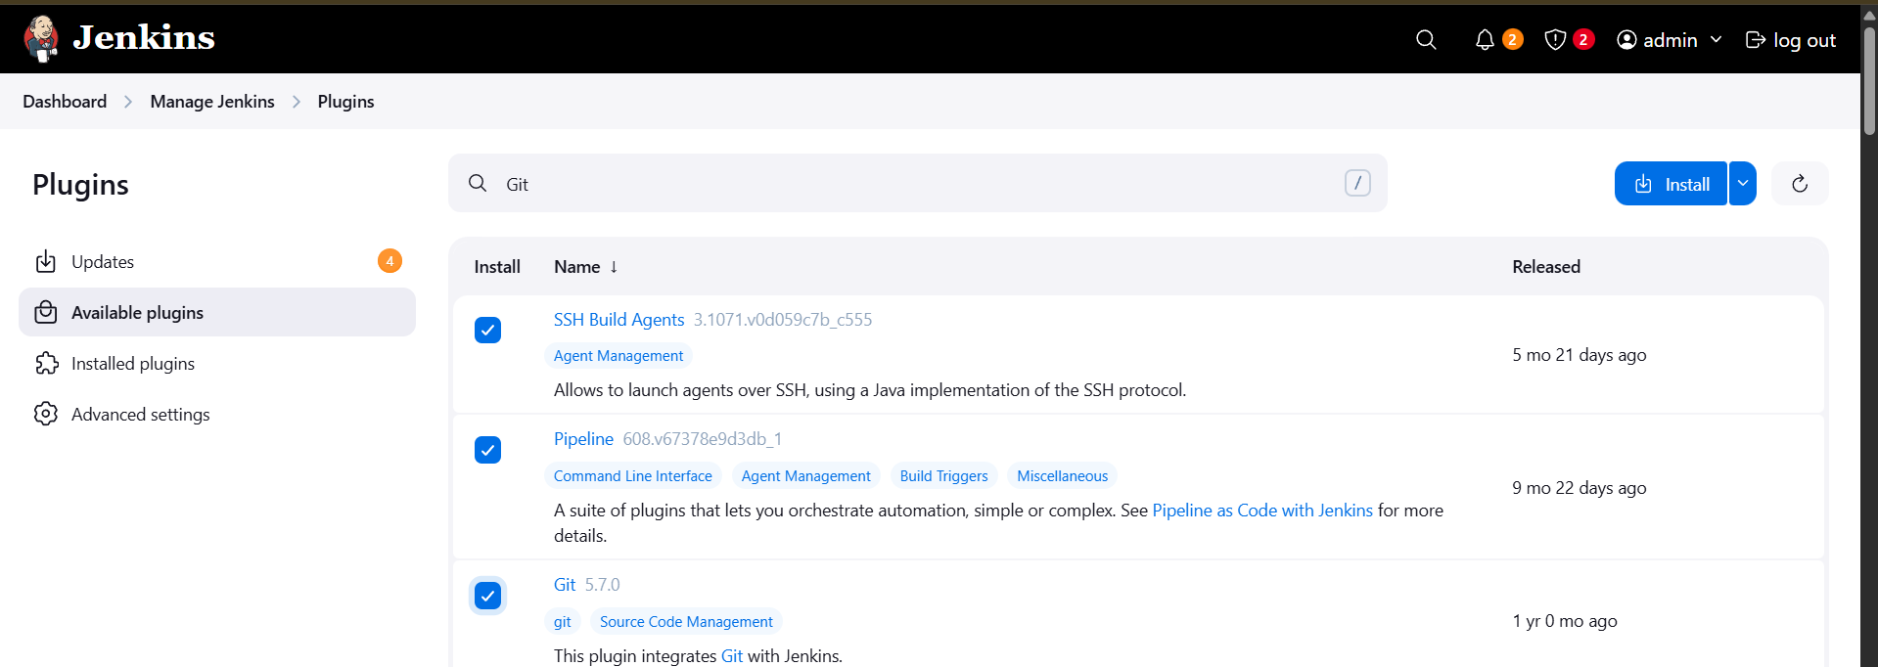
- Restart Jenkins after the plugin installation completes.

Step 3: Create Jenkins Credentials
- Navigate to Manage Jenkins → Credentials → System → Global credentials (unrestricted).
- Click Add Credentials.
- Enter the following details:
  - Kind: Username with password
  - Scope: Global
  - Username: natasha
  - Password: (provided password)
  - ID: ssh-natasha-id
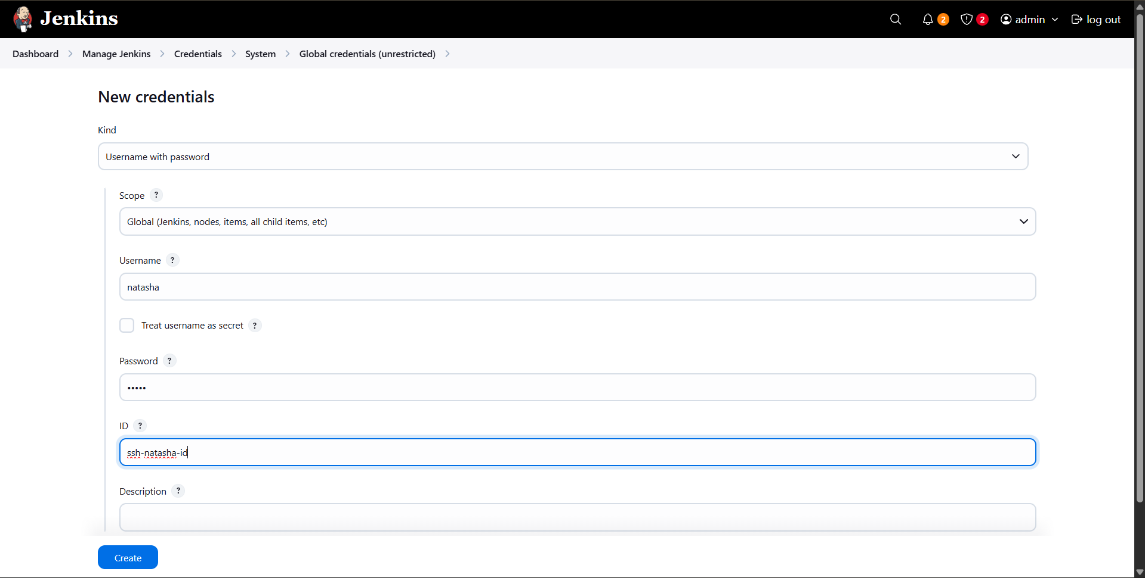
- Click Create.

Step 4: Create Storage Server Node
- Navigate to Manage Jenkins → Nodes → New Node.
- Enter Storage Server as the node name.
- Select Permanent Agent and click Create.

Node Configuration
- Configure the node as follows:
  - Remote root directory: /var/www/html
  - Labels: ststor01
  - Usage: Use this node as much as possible
  - Launch method: Launch agents via SSH
  - Host: ststor01.stratos.xfusioncorp.com
  - Credentials: natasha (ssh-natasha-id)
  - Host Key Verification Strategy: Non verifying Verification Strategy
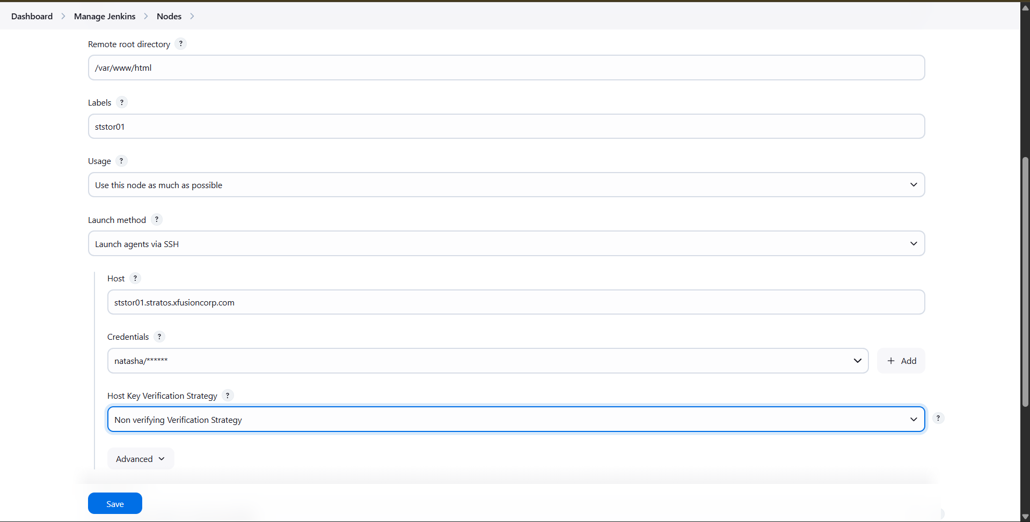
- Click Save.

Step 5: Prepare Storage Server
- SSH into the Storage Server:
  - ssh natasha@ststor01
- Change ownership of the document root:
  - sudo chown -R natasha:natasha /var/www/html
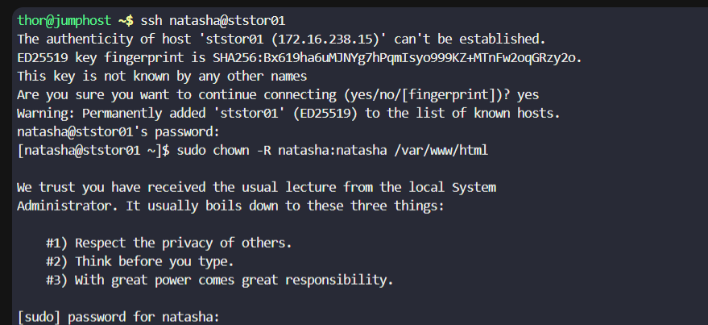
- Install Java on the server:
  - sudo yum install java-21-openjdk –y
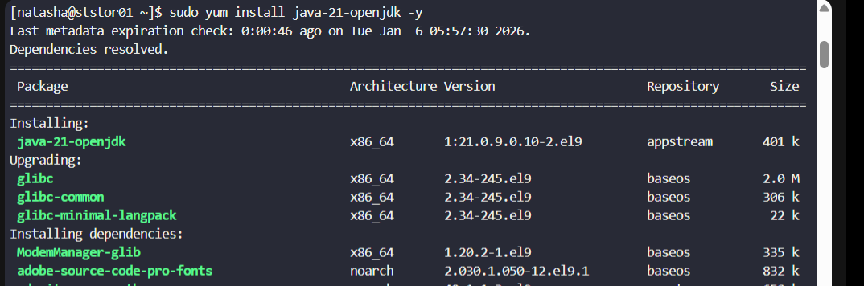
- Return to Jenkins and ensure the node status shows Connected.

Step 6: Access Gitea Repository
- Open the Gitea URL in a browser.
- Log in using the sarah user credentials.
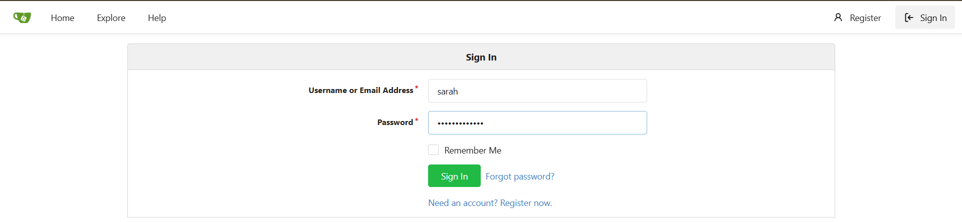
- Open the web_app repository.
- Copy the repository clone URL.

Step 7: Create Jenkins Pipeline Job
- From the Jenkins dashboard, click New Item.
- Enter the job name: xfusion-webapp-job.
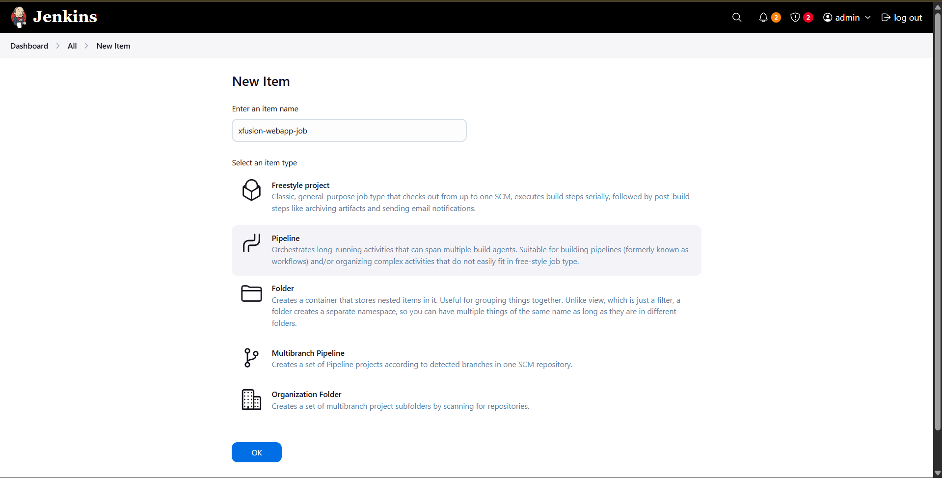
- Select Pipeline and click OK.

Step 8: Configure Pipeline Script
- In the job configuration page, scroll to the Pipeline section.
- Set Definition to Pipeline script.
- Paste the following script:
pipeline {
agent {
label 'ststor01'
}
stages {
stage('Deploy') {
steps {
git branch: 'master',
url: 'http://git.stratos.xfusioncorp.com/sarah/web_app.git'
}
}
}
}
- Ensure Use Groovy Sandbox is enabled.
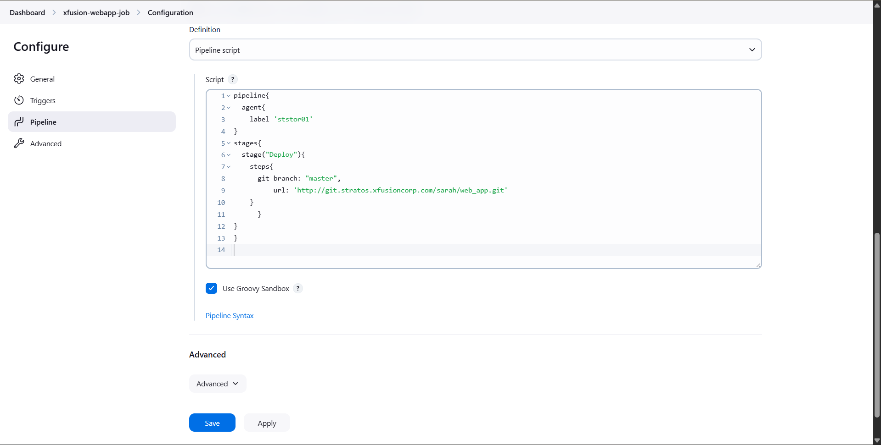
- Click Save.

Step 9: Run and Verify
- Click Build Now.
- Verify the build completes successfully.
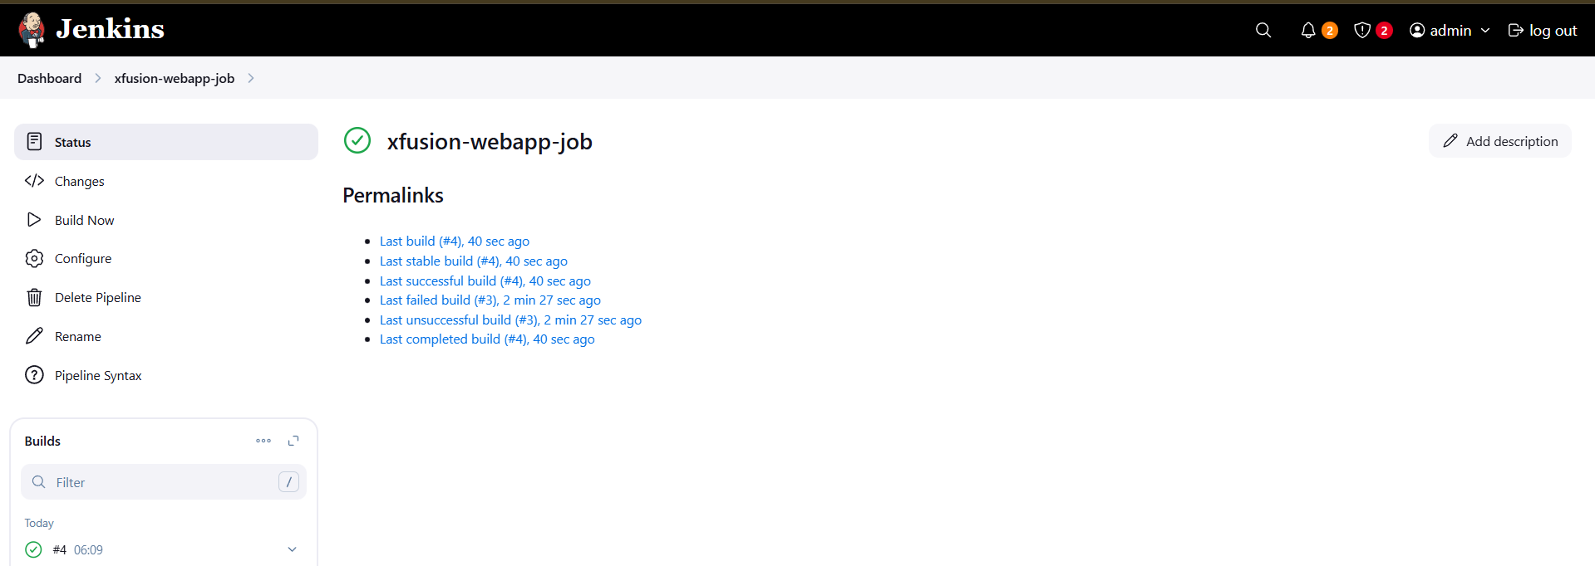
- Confirm files are deployed under /var/www/html.
- Access the application using the Load Balancer URL to validate deployment.
